<https://tpchd.org/healthy-places/food-safety/food-worker-card/manual/>

[Home](https://tpchd.org/) » [Healthy Places](https://tpchd.org/healthy-places/) » [Food Safety](https://tpchd.org/healthy-places/food-safety/) » [Food Worker Card](https://tpchd.org/healthy-places/food-safety/food-worker-card/) » **Washington State Food Worker Manual**

**Washington State Food Worker Manual**

[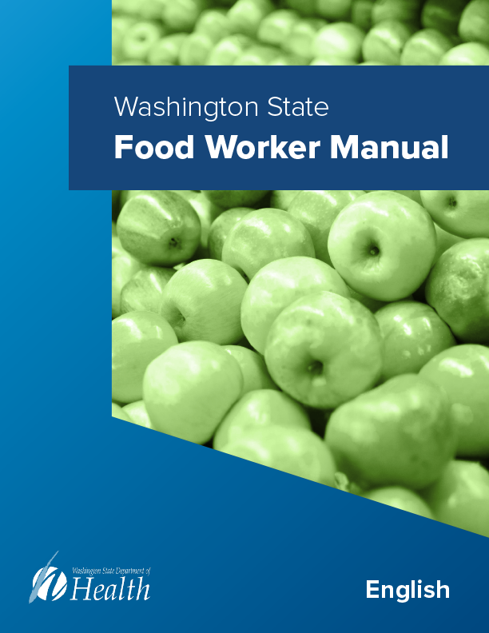](https://tpchd.org/wp-content/uploads/2023/12/Washington-State-Food-Worker-Manual-1.pdf)

**Learn how to store, prepare, and serve food safely!**

Food safety knowledge prevents foodborne illness. You can use what you learn from the manual at work and home.

**Need a Food Worker Card?**

Learn more about [Food Worker Cards](https://tpchd.org/healthy-places/food-safety/food-worker-card/).

**More languages**

The languages below are still being reviewed by food safety staff around the state. We want to make sure each language is accurate and easy to understand.

[دليل العاملين في مجال الطعام لولاية واشنطن](https://tpchd.org/wp-content/uploads/2023/12/Washington-State-Food-Worker-Manual-Arabic-1.pdf)

العربية (Arabic)

[ဝါရှင်တန်ပြည်နယ် စားဖိုဆောင်ဝန်ထမ်း လက်စွဲ](https://tpchd.org/wp-content/uploads/2023/12/Washington-State-Food-Worker-Manual-Burmese-1.pdf)

မြန်မာဘာသာ (Burmese)

[សៀវភៅណែនាំសម្រាប់ពលករក្នុងវិស័យចំណីអាហាររបស់រដ្ឋវ៉ាស៊ីនតោន](https://tpchd.org/wp-content/uploads/2023/12/Washington-State-Food-Worker-Manual-Khmer-1.pdf)

ភាសាខ្មែរ (Khmer)

[한국어  
(Korean)  
워싱턴 주 식품 종사자 매뉴얼](https://tpchd.org/wp-content/uploads/2023/12/Washington-State-Food-Worker-Manual-Korean-1.pdf)

[Русский  
(Russian)  
Пособие для работников пищевой ромышленности штата Вашингтон](https://tpchd.org/wp-content/uploads/2023/12/Washington-State-Food-Worker-Manual-Russian-1.pdf)

[Español  
(Spanish)  
Manual para trabajadores del sector de alimentos del estado de Washington](https://tpchd.org/wp-content/uploads/2023/12/Washington-State-Food-Worker-Manual-Spanish-1.pdf)

[Tagalog  
(Filipino)  
Manwal ng Manggagawa ng Pagkain ng Estado ng Washington](https://tpchd.org/wp-content/uploads/2023/12/Washington-State-Food-Worker-Manual-Tagalog.pdf)

[ภาษาไทย  
(Thai)  
คู่มือสำหรับพนักงานด้านอาหารของรัฐวอชิงตัน](https://tpchd.org/wp-content/uploads/2023/12/Washington-State-Food-Worker-Manual-Thai-1.pdf)

[ਪੰਜਾਬੀ  
(Punjabi)  
ਵਾਸ਼ਿੰਗਟਨ ਸਟੇਟ ਫੂਡ ਵਰਕਰ ਮੈਨੁਅਲ](https://tpchd.org/wp-content/uploads/2023/12/Washington-State-Food-Worker-Manual-Punjabi.pdf)

[繁體中文  
(Traditional Chinese)  
華盛頓州食品 從業人員手冊](https://tpchd.org/wp-content/uploads/2023/12/Washington-State-Food-Worker-Manual-Traditional-Chinese.pdf)

[简体中文  
(Simplified Chinese)  
华盛顿州食品 工作者手册](https://tpchd.org/wp-content/uploads/2023/12/Washington-State-Food-Worker-Manual-Simplified-Chinese.pdf)

[Tiếng Việt  
(Vietnamese)  
Sổ tay Hướng dẫn Nhân viên Thực phẩm của Bang](https://tpchd.org/wp-content/uploads/2023/12/Washington-State-Food-Worker-Manual-Vietnamese.pdf)

**Have feedback on the translations?**

Email your suggestions to [food@tpchd.org](mailto:food@tpchd.org).